Homework 5: Deep Dive Blueprint

Workflow: Vendor Invoice & Purchase Order Audit
Name: Revital Yoffe
Course: BAN5600-800

1. Problem Description

The workflow chosen for this project is the process of comparing vendor invoices to purchase orders before approval. This process is critical for ensuring that vendors charge accurately and that the organization does not overpay or authorize false invoices. Currently, this procedure is carried out manually by opening invoices, reviewing critical facts, and comparing them to purchase order records in a separate system.

This workflow is an excellent candidate for automation since it is repetitive, follows clear business standards, and is totally dependent on digital data such as PDFs, emails, and system records. Small mistakes in this process can result in financial loss, duplicate payments, or invoice processing delays.

2. Scale & Stats

This process occurs on a weekly or even daily basis, depending on invoice volume. On average, dozens to hundreds of invoices need to be examined per month. Each invoice may take several minutes to evaluate, especially if discrepancies are discovered or information is difficult to locate.

Overall, this procedure can take many hours per week and necessitates constant attention to detail. Because of the volume and repetition, it is very susceptible to human error.

3. Manual Checklist (As-Is Process)

The current manual process includes the following steps:
- Open the accounts payable email inbox or invoice folder.
- Download vendor invoice PDFs or attachments.
- Open the purchasing system and search for the corresponding purchase order.
- Compare key details such as vendor name, invoice number, and total amount.
- Check if the invoice total matches the purchase order total.
- Make a decision (approve, review, or reject) based on the comparison.
- Log the results in an Excel audit tracker.
- Save and organize the reviewed invoice in the appropriate folder.

4. Input / Output Map
Inputs:
- Vendor invoice PDFs (email attachments or downloads)
- Purchase order data from internal system
- Excel audit tracker
Outputs:
- Updated audit tracker with status (Pass, Fail, Needs Review)
- Organized invoice files
- Notes for discrepancies or vendor follow-ups
A completed workflow results in a clear record of which invoices were approved and which require further action.

5. As-Is Visuals
Figure 1: Vendor Invoice Example
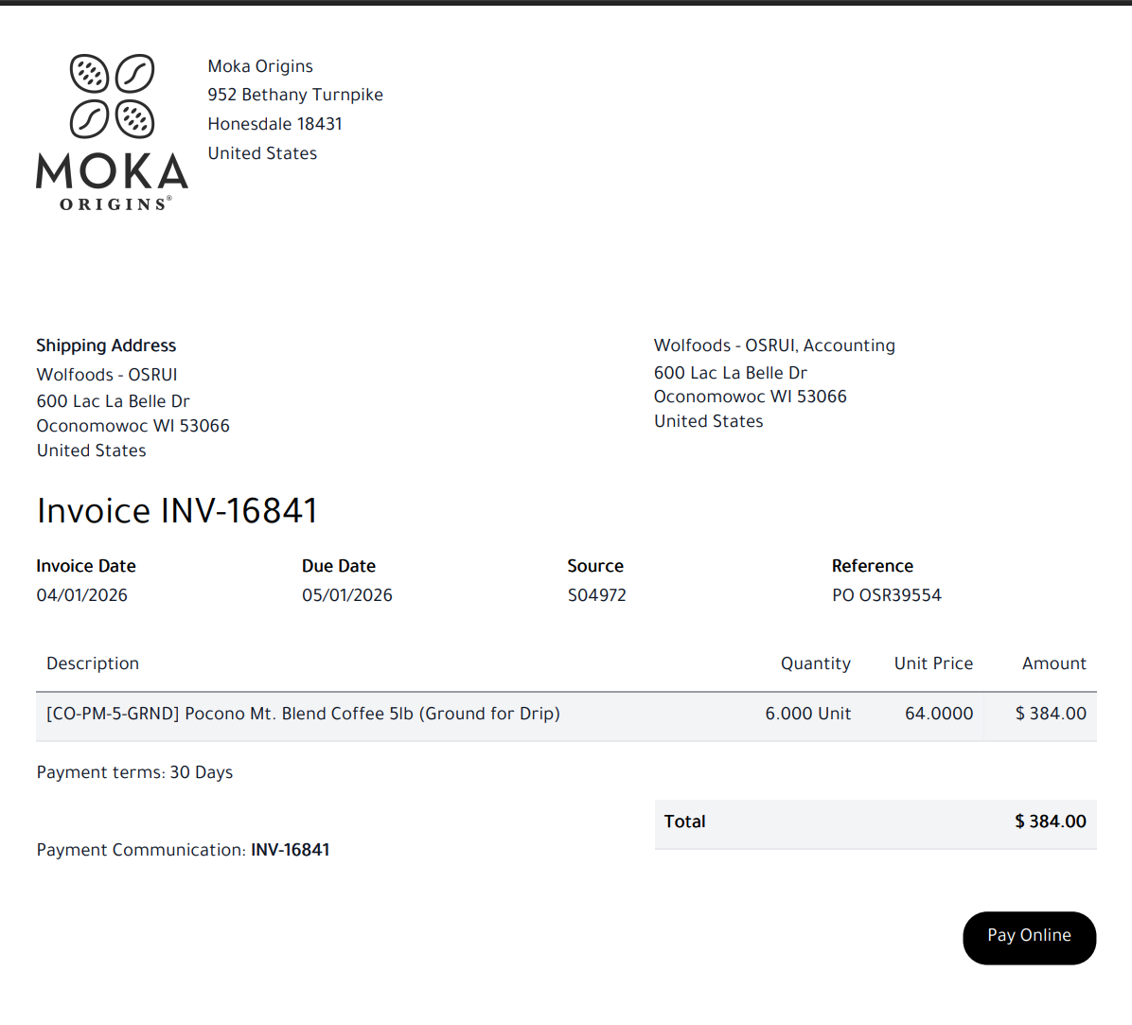
Figure 2: Comparison of vendor invoice and purchase order showing matching values used for manual verification.
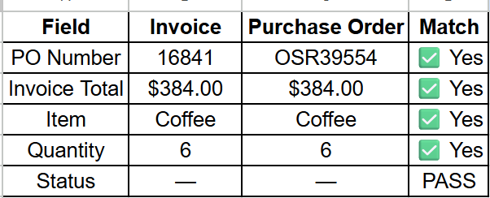
This table represents the manual comparison process used to verify that invoice details match the corresponding purchase order before approval.

Figure 3: Folder containing vendor invoice files prior to manual review.


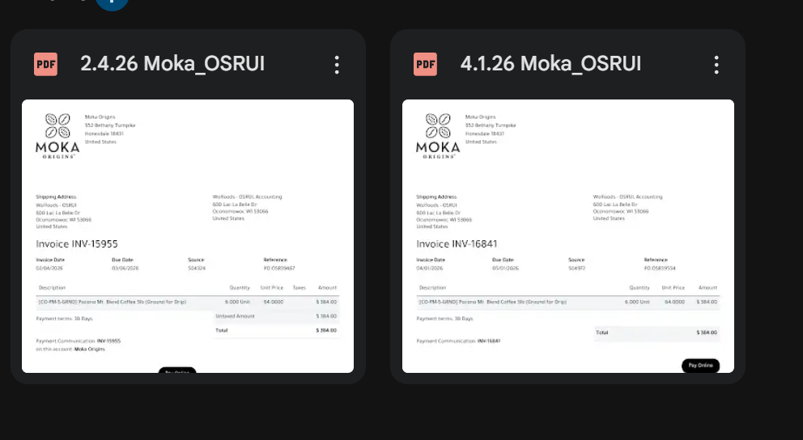
This figure shows how invoice files are organized before processing, where each file must be manually opened and reviewed against the corresponding purchase order.
Figure 4: Invoice Approval Decision Flowchart
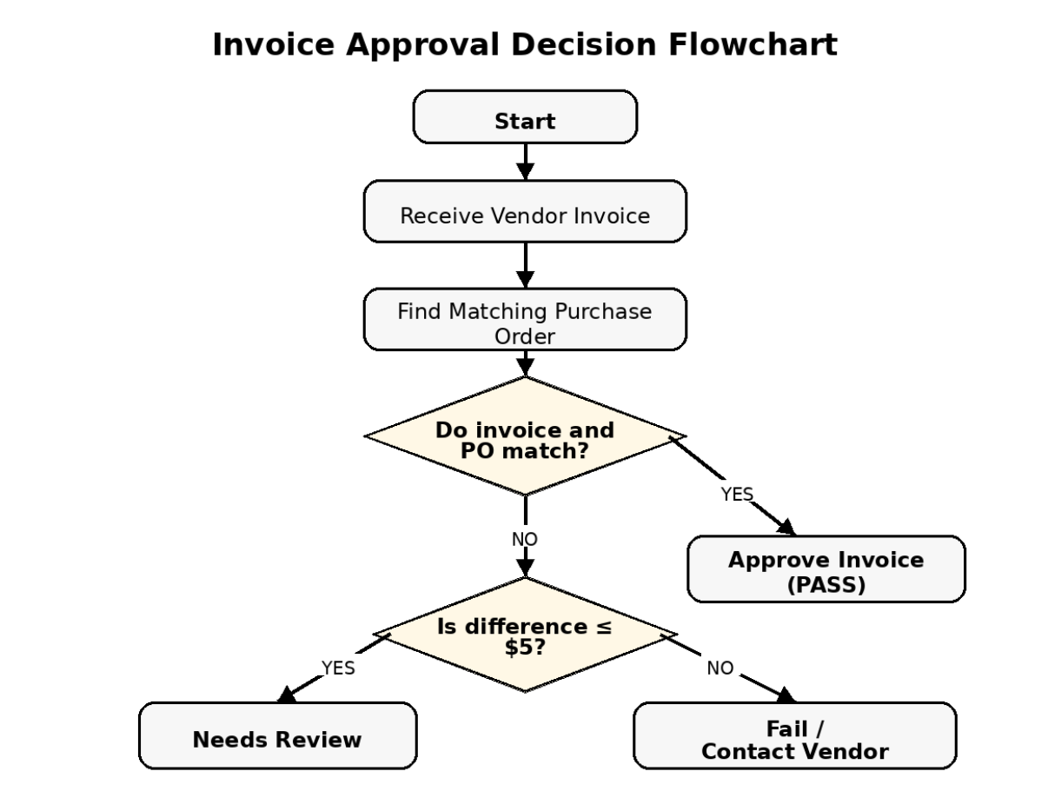
This flowchart illustrates the manual decision-making process used to compare vendor invoices against purchase orders. Based on the results of the comparison, invoices are either approved, flagged for review, or escalated for vendor follow up.

Figure 5: Final audit tracker used to record invoice review outcomes.

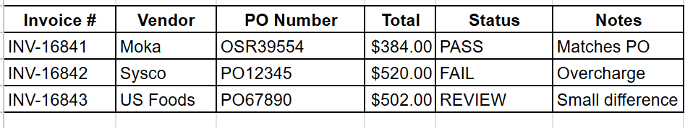
This tracker is used to document the final status of each invoice after the manual review process is completed.

6. Friction Inputs
The current invoice review process contains several inefficiencies that make it time-consuming and prone to errors. First, the process is highly repetitive. The same steps must be completed for every invoice, including opening files, locating purchase orders, and comparing multiple fields. Second, the workflow requires switching between multiple systems such as email, file folders, and the purchase order system. This constant switching slows down the process and reduces efficiency. Third, there is a high risk of human error. Since all comparisons and data entries are done manually, mistakes such as overlooking discrepancies or entering incorrect values can occur. Another issue is that there is no automated way to flag discrepancies. The reviewer must manually identify and investigate any differences, which increases the workload. Finally, the process often requires judgment when small differences occur, adding complexity and inconsistency to decision-making.
Overall, these friction points highlight why this workflow is a strong candidate for automation.

7. Python Toolkit

The following Python libraries would be used to automate this workflow:

Category | Library | Purpose
Data Extraction | PyPDF2 / pdfplumber | Extract invoice data from PDFs
Data Manipulation | pandas | Compare invoice data with purchase order data
Excel Automation | openpyxl | Update audit tracker automatically
File Management | os, glob | Locate and organize invoice files
Email Integration | ezgmail | Download invoice attachments
Reporting | smtplib | Send alerts for discrepancies

8. Automation Logic (Preview)

if invoice_total == po_total and vendor_name == po_vendor:
status = "Pass"
elif abs(invoice_total - po_total) <= 5:
status = "Needs Review"
else:
status = "Fail"

This logic demonstrates how the manual decision-making process can be translated into a rule-based automation using Python.

